|  |  |  |  |
| --- | --- | --- | --- |
| **Name of Student: NINAD AVINASH PATIL** | | | |
| **Roll No: 33** | | **Lab Practical Number: 3(A).1** | |
| **Title of Lab Practical: Design a C# application to Read and Write data to text file and binary file Design appropriate GUI.** | | | |
| **DOP: 17/03/2021** | | **DOS: 24/03/2021** | |
| **CO Mapped: CO1** | **PO Mapped: PO3, PO5, PO7,**  **PO12, PSO1, PSO2** | **Faculty Signature:** | **Marks:** |

**Practical No 3(A).1**

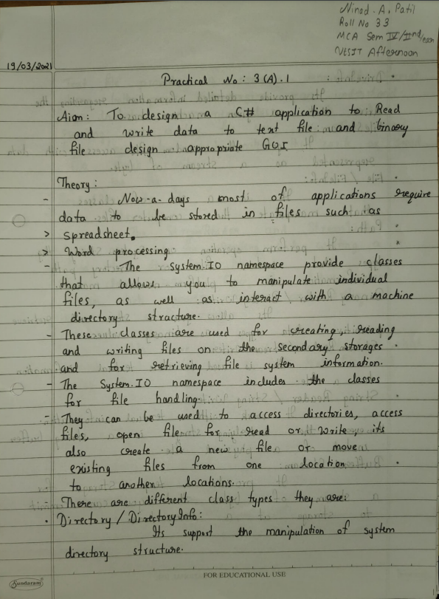

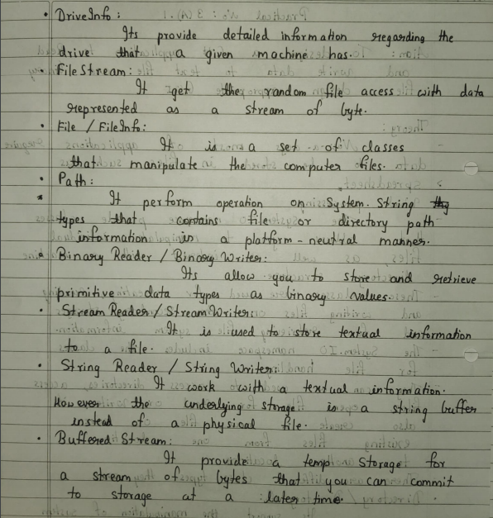

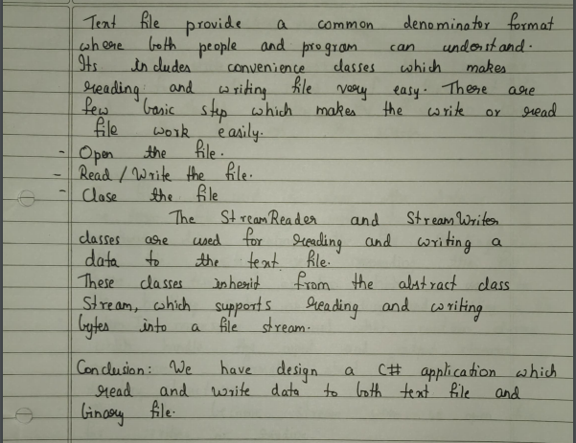

**Code:**

using System;

using System.Collections.Generic;

using System.ComponentModel;

using System.Data;

using System.Drawing;

using System.Linq;

using System.Text;

using System.Windows.Forms;

using System.IO;

namespace textfile

{

public partial class Form1 : Form

{

public Form1()

{

InitializeComponent();

}

private void button1_Click(object sender, EventArgs e)

{

using (StreamWriter sw = new StreamWriter("E:\\file.txt"))

{ string w = richTextBox1.Text;

sw.Write(w);

if (File.Exists("E:\\file.txt"))

{ label3.Text = "File write successfully"; }

else

{ label3.Text = "Failed to write a file"; }

}

}

private void button2_Click(object sender, EventArgs e)

{

if (File.Exists("E:\\file.txt"))

{ using (StreamReader sr = new StreamReader("E:\\file.txt"))

{ richTextBox1.Clear();

string line = sr.ReadToEnd();

richTextBox1.Text = line;

label3.Text = "File read successfully";

}

}

else

{

label3.Text = "Failed to read a file";

}

}

FileStream fs = new FileStream("E:\\file.bin", FileMode.Create, FileAccess.Write);

private void button3_Click(object sender, EventArgs e)

{ BinaryWriter bw = new BinaryWriter(fs);

bw.Write(richTextBox1.Text);

bw.Close();

MessageBox.Show("File write successfully");

}

private void button4_Click(object sender, EventArgs e)

{

if (File.Exists("E:\\file.txt"))

{ FileStream fs1 = new FileStream("E:\\file.bin", FileMode.Open);

BinaryReader br = new BinaryReader(fs1);

richTextBox1.Text = br.ReadString();

MessageBox.Show("File read successfully");

}

else

{

MessageBox.Show("File not found");

}

}

private void button5_Click(object sender, EventArgs e)

{

richTextBox1.Clear();

}

}

}

**Output:**

